GED activation – Text

# Colors used

# Text

## **Screen 1**

Hi Team Blue Colleague! [Gilroy Bold-24]

Thanks for joining us on this Group Ecosphere Day. Make yourself ready for a day full of Group energy, lots of enthusiasm, inspiration and an enlightening view on the future of KBC. [Gilroy – 17]

Jour journey starts NOW! [Gilroy Bold – 17]

Scan the QR-codes throughout the morning sessions in which Johan Thijs, Erik Luts and Karen Van De Woestyne will elaborate on the ecosphere strategy to activate to participate and win grand prizes! Enjoy your refreshing breakfast. At 9 o’clock we start with our Ecosphere Journey and this journey is all about the triple win. [Gilroy – 17]

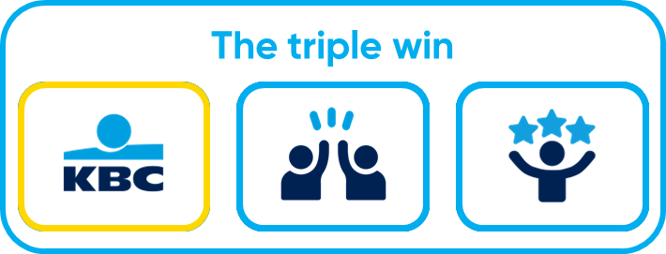

KBC: the orchestrator of the triple win [Gilroy Bold – 17]  
As an orchestrator, KBC creates scalable ecosystems in which the sum of the parts yields more than the individual contributions. By seamlessly integrating partners across different customer journeys, we can anticipate and fulfill the customer’s needs, leading to increased core product sales [Gilroy – 17]

Scan the other QR codes to win! [Gilroy Bold – 17]

KBC [Gilroy Bold – 32]



The Customer [Gilroy Bold – 32]



The Partner [Gilroy Bold – 32]

## **Screen 2**

Welcome back! [Gilroy Bold-24]

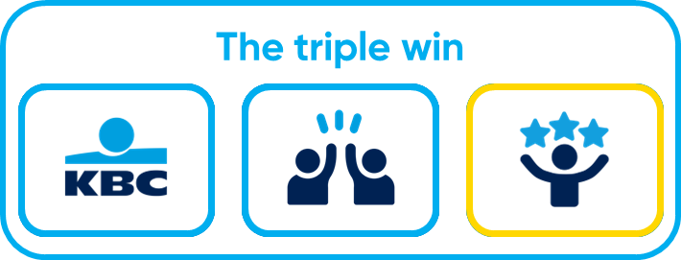2 QR codes down one to go! With the S.T.E.M The Ecosphere strategy we not only aim to sell more products. We also want to Save Time and Earn Money for the customer! [Gilroy – 17]

The Customer: [Gilroy Bold – 17]

A seamless, personalised experience through one trusted platform: the KBC Mobile. Customers get access to relevant solutions, tailored to their intentions and needs, without frustration or interruptions [Gilroy – 17]

Scan the other QR codes to win! [Gilroy Bold – 17]



KBC [Gilroy Bold – 32]

The Partner [Gilroy Bold – 32]

The Customer [Gilroy Bold – 32]